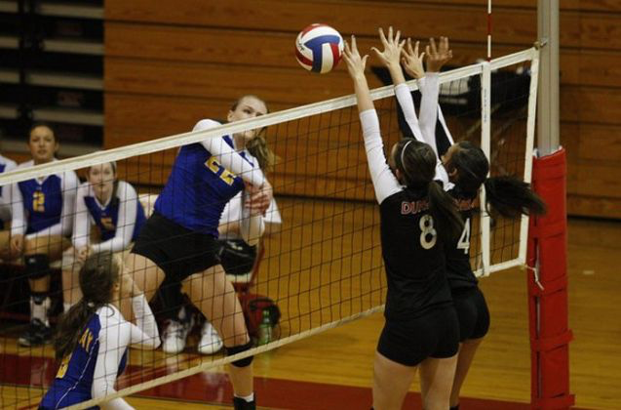
Please Join us and support our inaugural Volleyball season
All matches begin at 3:30pm
Monday, January 25th Rooftop @ Revere (SOMA Rec)
Friday, January 29th Rooftop @ BVHM (BVHM Gym)
Monday, February 1st Rooftop @ Carmichael (SOMA Rec)
Wednesday February 3rd Everett @ Rooftop (Everett Gym)
Wednesday February 10th Lick @ Rooftop (Lick Gym)
Friday February 12th Rooftop @ MLK Jr. (MLK Gym)
Wednesday February 17th Roosevelt @ Rooftop (Rsvt Gym)
Monday February 22nd Lilienthal @ Rooftop (Rich Rec)
Wednesday February 24th Rooftop @ Brown (Brown Gym)

