Home is Where the Heart Is…
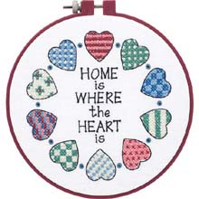
Rooftop Burnett Student Council

